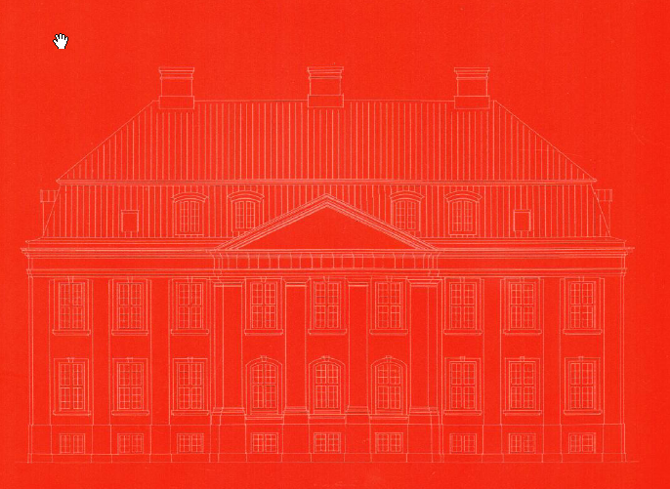

COPENHAGEN PAINTERS' GUILD

WINDOW PROJECT I

AMALIEGADE 31

CONCLUDING REPORT AUTUMN 2011

10 YEARS OF THE COPENHAGEN PAINTERS' GUILD WINDOW PROJECT

In order to document the natural wear and tear over time of a painted surface, in the winter of 1999-2000, the Copenhagen Painters' Guild initiated a project in which the windows of the eastern facade of the guild's property on Amaliegade were treated with 9 different paint products ranging from acrylic based to linseed oil based paint. The treatment was based on three different removal levels from partial to total removal of existing paint (see plan drawing).
The aim was not to conduct an experiment according to scientifically measurable methods but as a practical examination of craftsmanship. The painting was therefore carried out under conditions commonly occurring within the construction industry. Likewise, a system of inspection was selected primarily based on visual inspection. Such an assessment is also the usual starting point for a craftsmanlike evaluation of the regular condition of windows.

Results and conclusions – summary
Despite a limited experimental sample, a clear picture is painted of the results that may contribute as a guide to the choice of material for the future.
With regard to staining of the surface, the trial demonstrates that acrylic paints together with the linseed oil paint section D lasts the longest without staining for 5 to 6 years.
The recording of the paint surface durability shows acrylic based paints are the least durable and linseed oil based paints as those that performed best.
The recording of rust on the fittings reveals exactly the same picture with extensive rust on the acrylic painted layer - and partial rust on the alkyd painted layer - in the very first year of the study period. In contrast to this, 2 linseed oil painted - section D – at the end of the study period still remains free from rust.
In 2010 none of the painted surfaces remain intact. All sections in 2009 and 2010 show a chalking of the surface which means that the binding agents in the surfaces have now leached. There are no signs of mould / mould growth on any of the window sections.

HOW TO READ THE RESULTS

In the building plans - which include an overview of the painting materials and the three varying clearing levels –there is a ‘code’ listed next to each window, consisting of four letters and one number. The letters pertain to the four parameters shown in the table below and compare with the corresponding numerical values.

Visual recording of the surface, final year of the project, October 2010

A Paint surface
1. Intact 2. Minor cracks 3. Crazing
4. Signs of peeling 5. Major signs of peeling

B Staining and level of dirt
1. No staining 2. Staining 3. Chalking
4. Loose dirt 5. Firmly established dirt
C Other
1. No mould / mould growth 2. Light mould / mould growth 3. Excessive mould / mould growth
4. No exudation of resin 5. Exudation of resin
D Fittings
1. No rust 2. Rust spots 3. Major rust spots

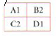
Example Coat of paint intact with staining and light mould growth. No rust.

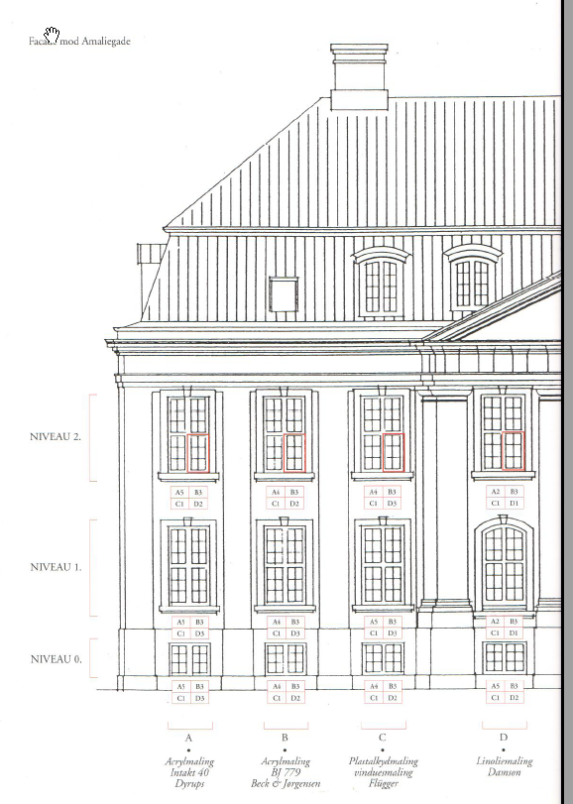
Facade toward Amaliegade

LEVEL 2

LEVEL 0

LEVEL 1

